Woocommerce

Citcon Gateway User Guide

|  |  |  |  |  |
| --- | --- | --- | --- | --- |
| Status：  【  】 Draft  【√】 Release  【 】 Amended | Name of File | USG | District | HQ |
| Author | Rui | * Security classification | Confidential |
| Create Data | 2020-2-23 | Examine and approve |  |
| Copyright | Citcon USA LLC | Version | V1.3.0 |

History

|  |  |  |  |  |  |
| --- | --- | --- | --- | --- | --- |
| Version | Status | Description | Editor | Date | Remark |
| 1.0.0 | Create |  | Rui | 2020.02.17 |  |
| 1.0.1 | Update | Add installation | Rui | 2020.02.24 |  |
| 1.1.0 | Update | Add Refund | Rui | 2020.02.25 |  |
| 1.1.1 | Update | Amended | Rui | 2020.02.27 |  |
| 1.3.0 | Update | Amended | Rui | 2020.03.19 |  |
|  |  |  |  |  |  |
|  |  |  |  |  |  |
|  |  |  |  |  |  |
|  |  |  |  |  |  |
|  |  |  |  |  |  |

Content

**Summary** **4**

Background 4

**Preconditions** **4**

Rules 4

Pay Method 4

WeChat Pay 4

Alipay 4

Feature 4

Pay 4

Refund 4

**Integration Guide** **4**

Installation 5

Checkout 5

Refund 7

# Summary

## Background

Our unique omnichannel payments technology makes it easy for customers to shop seamlessly from your online store, your mobile app, and your physical stores at their convenience.

Start accepting Alipay and WeChat Pay today through Citcon gateway plugin, it will provide countless opportunities for delighting shoppers, building loyalty, and increasing revenue.

Accept payments anytime, anywhere. Whether your business runs on desktop or mobile, we’ve got you covered. For online and in-person payment solutions, meet customer demand in any payment scenario.

# Preconditions

## Rules

### Pay Method

### WeChat Pay

### Alipay

* + - 1. China Union Pay

### Feature

### Pay

### Refund

# Integration Guide

This is a user guide to help WooCommerce merchants connect with Citcon payment Gateway through its store admin portal. It also shows how payment and refund transactions, through Alipay WeChat Pay and China Union Pay networks can be processed. Merchant can use it as a reference when testing out the end to end transaction flow.

## Installation

* 1. Download woocommerce plugin [here.](https://github.com/Citcon/woocommerce)

* 1. Upload​ ​wc_citcon.tar.gz​ ​to​ ​Wordpress​ ​plugins​ ​directory.​ ​On​ ​a​ ​Ubuntu​ ​installed​ ​at​ ​web root​ ​directory,​ ​the​ ​plugins​ ​directory​ ​is​ ​at​ ​/var/www/html/wp-content/plugins
  2. Run​ ​“tar​ ​-zxvf​ ​wc_citcon.tar.gz”.​ ​This​ ​will​ ​extract​ ​files​ ​into

/var/www/html/wp-content/plugins/citcon​ ​directory.​

* 1. ​There​ ​will​ ​be 3​ ​files:
* /var/www/html/wp-content/plugins/citcon/citconpay_methods.png
* /var/www/html/wp-content/plugins/citcon/citconpay.php
* /var/www/html/wp-content/plugins/citcon/redirect.php
  1. Open​ ​wp-admin​ ​in​ ​a​ ​browser,​ ​go​ ​to​ ​Plugins​ ​(/wp-admin/plugins.php)
  2. Activate​ ​Citcon​ ​Gateway​ ​for​ ​WooCommerce​ ​plugin

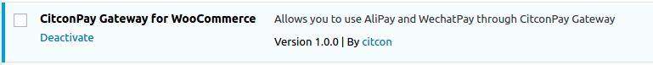

* 1. Go​ ​to​ ​WooCommerce->Settings,​ ​click​ ​on​ ​Checkout​ ​tab,​ ​scroll​ ​to​ the ​bottom,​ ​click​ ​on CitconPay​ ​to​ ​configure

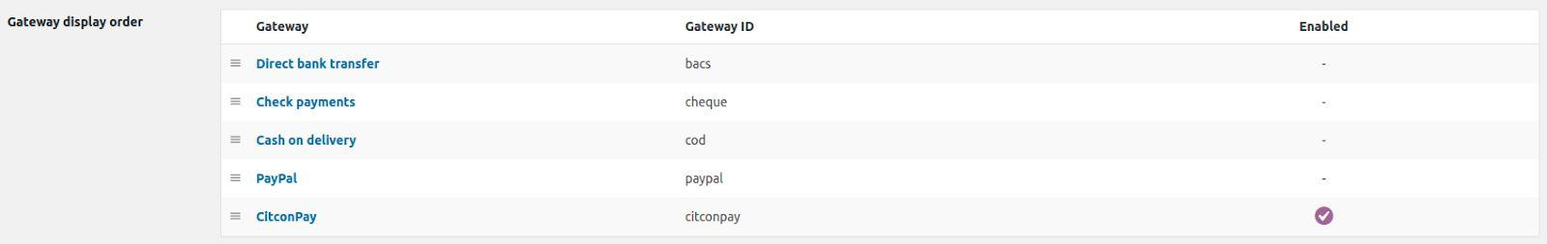

* 1. Enter​ ​API​ ​Token​ ​(aka​ ​CHOP​ ​Token),​ ​and​ ​select​ ​Test​ ​or​ ​Live​ ​environment​ ​accordingly. Please​ ​note​ ​that​ ​token​ ​and​ ​environment​ ​must​ ​match.​ ​Save​ ​changes.

*Note:

CHOP token is the merchant-specific token distributed by Citcon at the time of merchant onboarding. Please keep the token secure, as this is used for authenticating merchant API calls. You can contact Citcon sales representative, or go directly to CItcon dev page and click on “Try for free” to request a CHOP testing token.

<https://doc.citconpay.com/citconAPI/>

## Checkout Experience

* 1. Add​ ​items​ ​to​ the shopping ​cart,​ ​and​ ​proceed to payment.
  2. Select​ ​CitconPay​ ​as​ the ​payment​ ​method.
  3. Choose​ ​Alipay​ ​or​ ​WeChat​ ​Pay or Union Pay

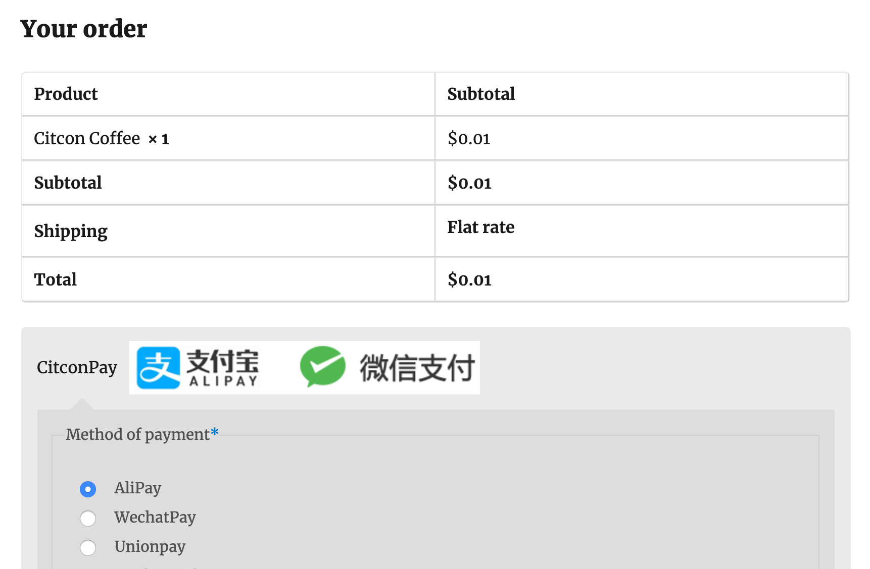

* 1. Click​ ​on​ ​Place​ ​Order. If you select AliPay or WechatPay, then page shows

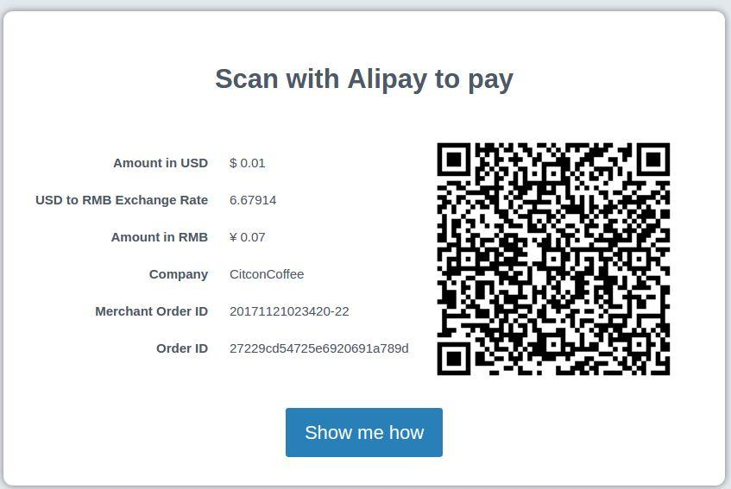

If you select Unionpay, then pages shows

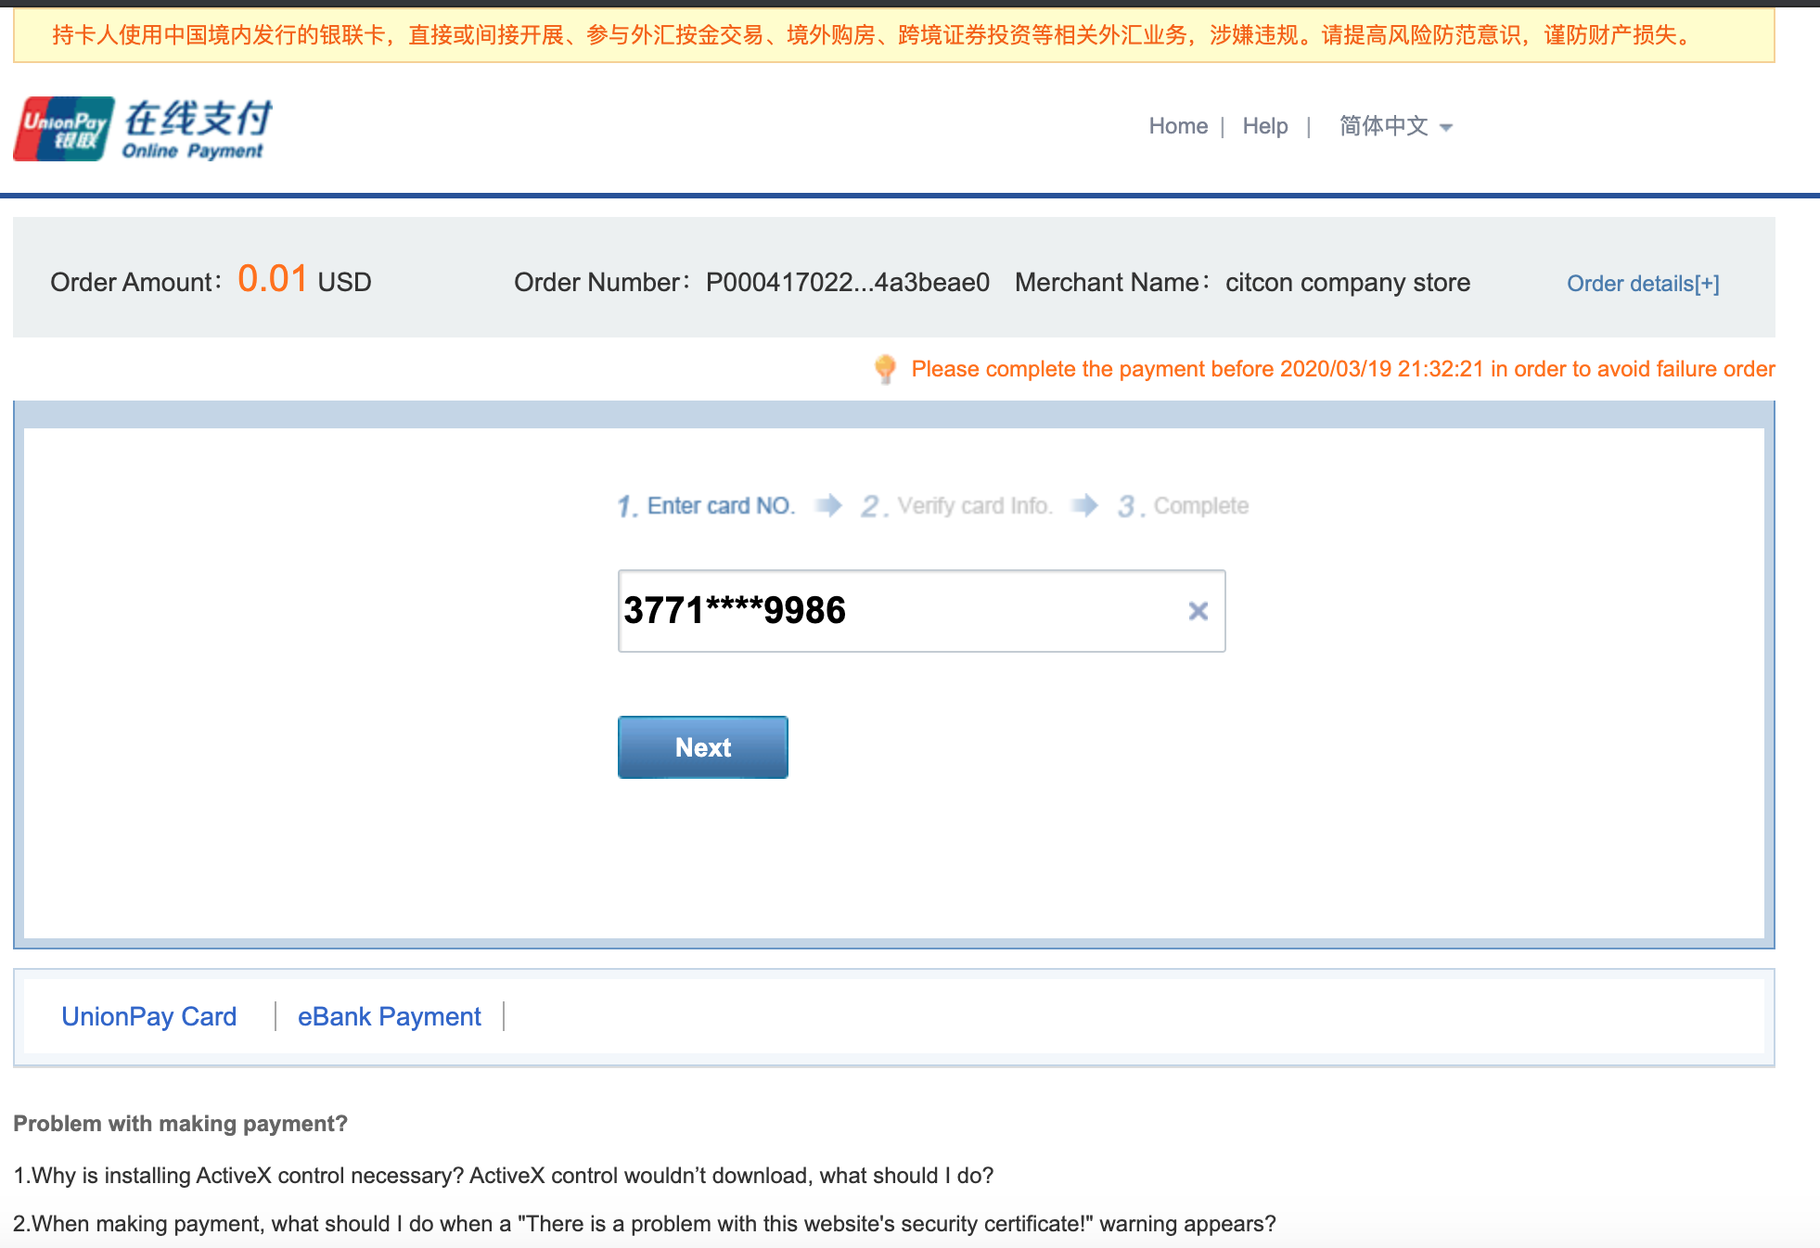

* 1. Use​ the ​Alipay/WeChat​ ​APP​ ​on​ a ​mobile​ ​device​ ​to​ ​scan​ ​the​ ​QR​ ​code​ ​on​ the ​screen.​ or type credit card information on the Unionpay payment page. After ​payment approved. The following screen will show if the payment is a success.

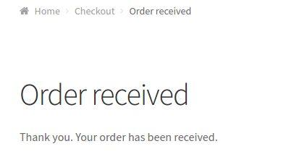

* 1. Asynchronously,​ ​after​ ​successful​ ​payment,​ ​order​ ​status​ ​is​ ​moved​ ​automatically​ ​from​ ​Pending Payment​ ​to​ ​Processing​ ​​​in​ ​wp-admin.

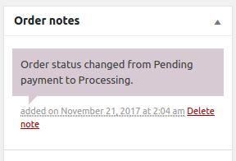

* 1. If the payment fails, the merchant website will show payment failed result to the user.

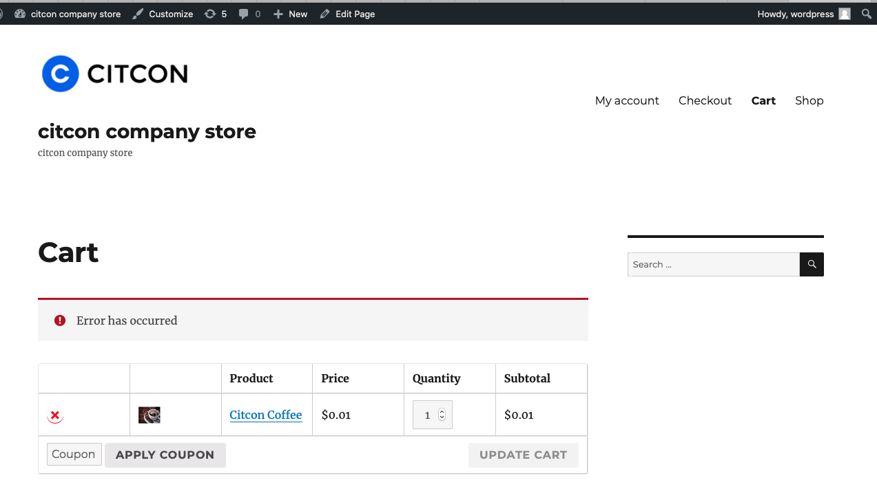

## Refund Process

* 1. Login to your website dashboard

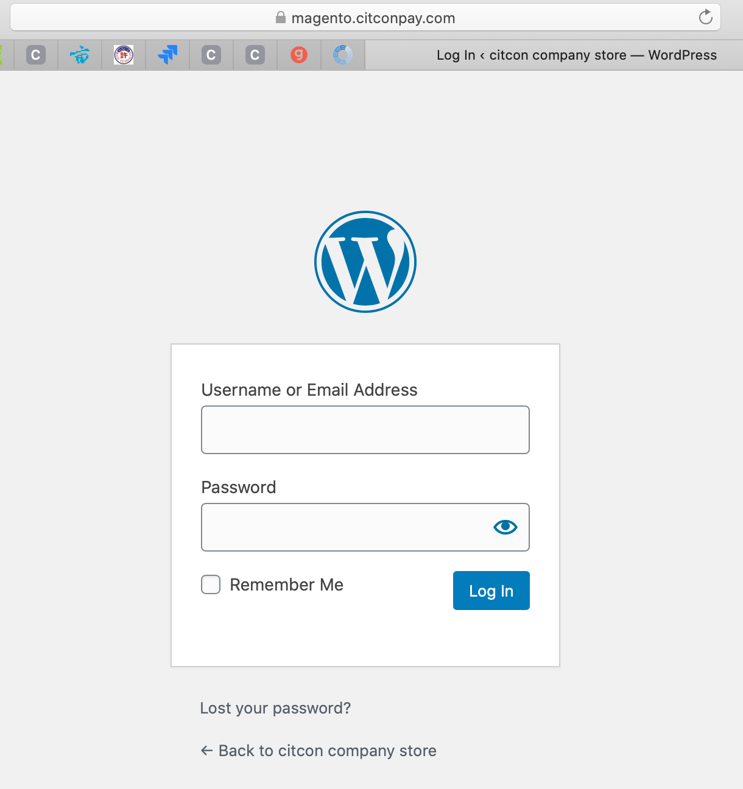

* 1. Select woocommerce from the left sidebar

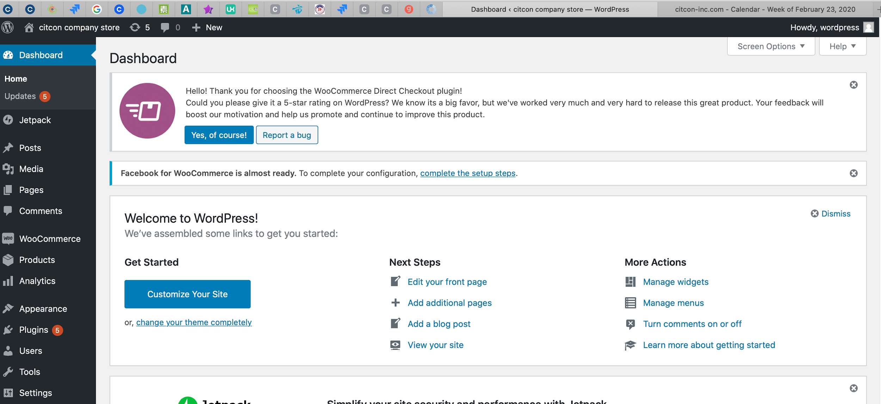

* 1. Click on Orders from Plugins

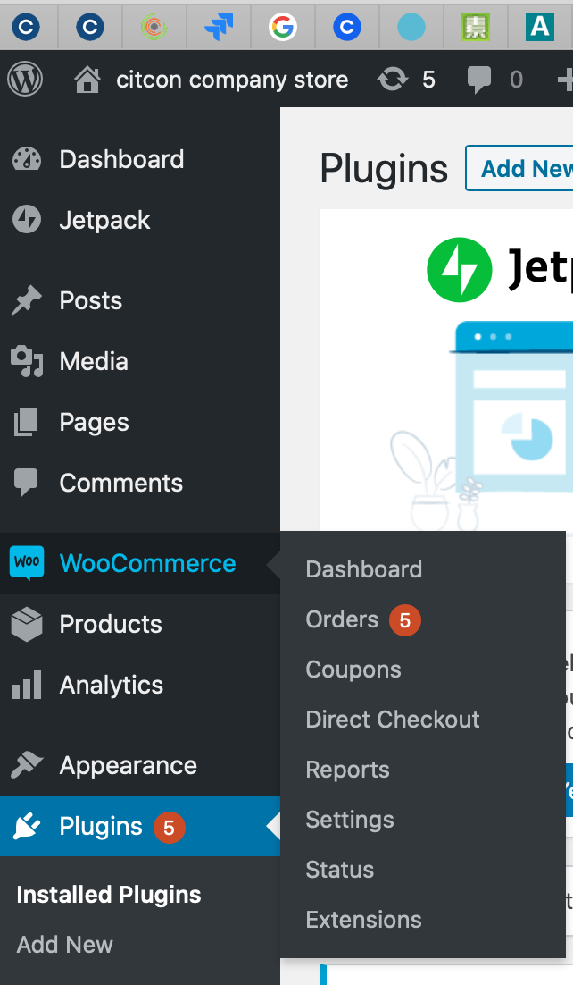

* 1. Select the order which you want to refund

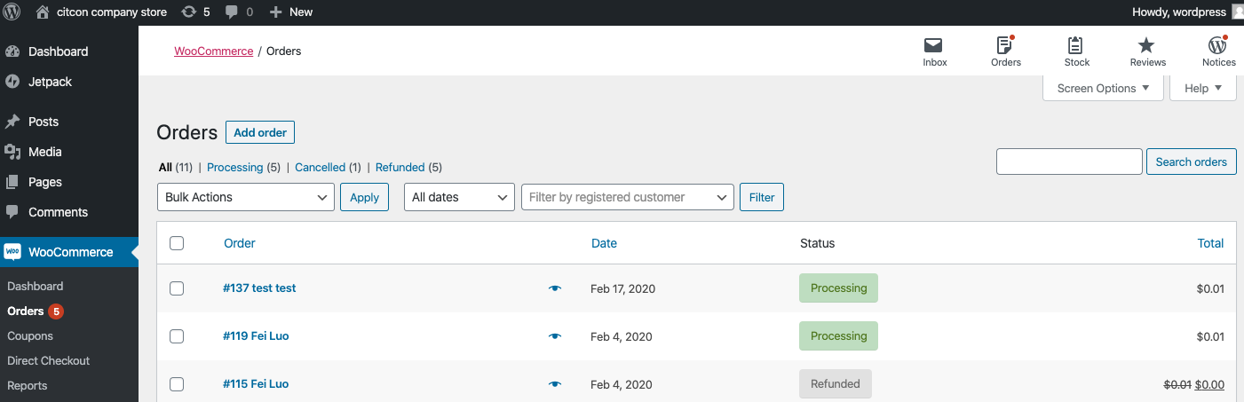

Notes,

Concerning Wechat Pay, Alipay, UnionPay,If order shows processing, it means the payment is already successful.

* 1. Click refund

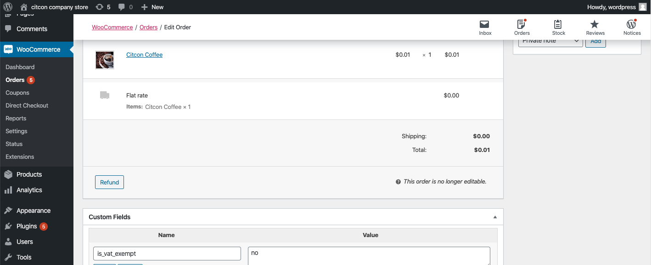

* 1. Type refund amount, then click refund via CitconPay

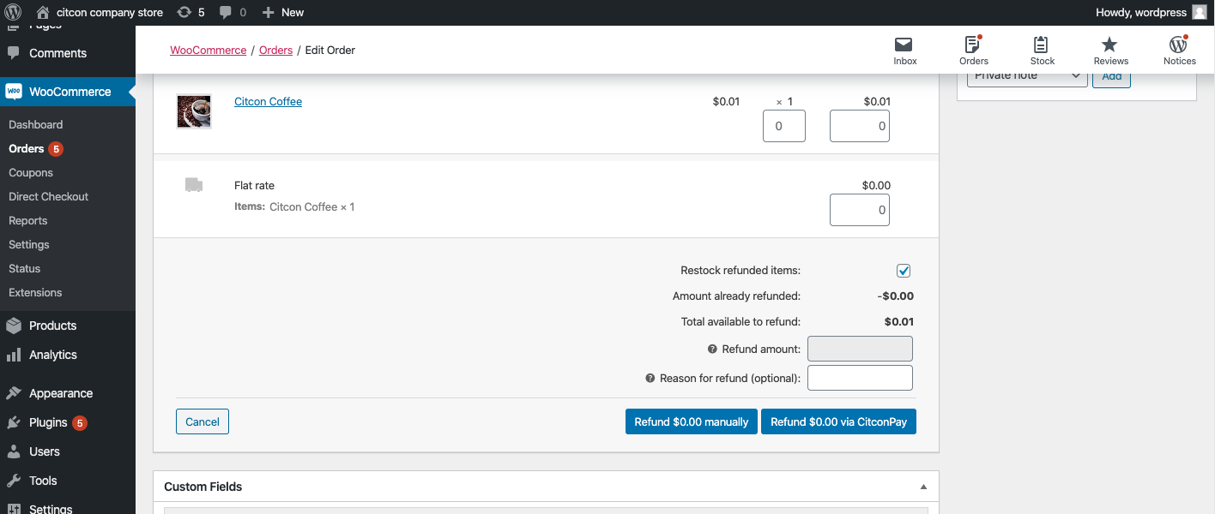

* 1. Double confirm refund

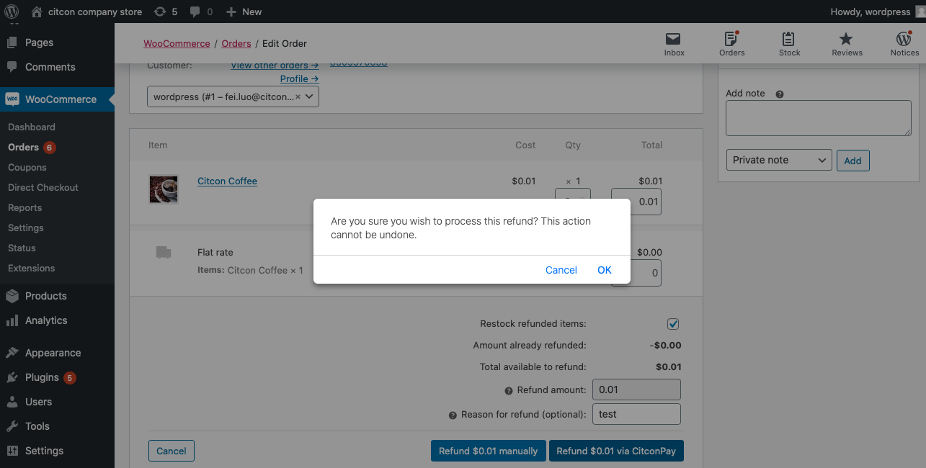

* 1. If the refund is successful, the website will show a refund successful result page.

